**Work - (Toastmaster) Life Balance**

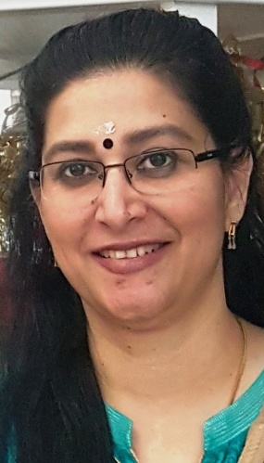**Now there is no life other than the Toastmaster life, so there is no point in discussing about ‘Work and Life’ but just Work and then (Toastmaster) Life.**

**If I look at the life for the past few months of any committed toastmaster, I don’t think anyone attended any social activities such as family get-togethers, movies or dinners. As it is the toastmaster contest season, these social activities were replaced with;**

* **Own Club Contests (Average club conducted the contest in 2 days)**
* **Other Club contests either as a judge or as a role player**
* **Own Area contest**
* **Other Area Contests, etc**

**In between we have our regular club meetings, other club meetings, demo meetings, excom meeting etc.**

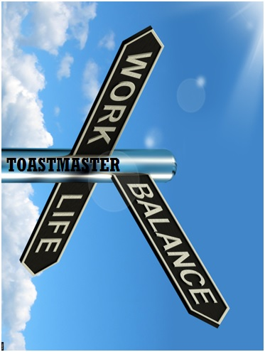**Normally, we are expected to be reaching home after work and stat helping the children for their exams, doing cleaning, cooking encouraging creating harmony at home.**

**Instead, after work we just begin our routine of practicing and preparing speeches, roles, Planning for the contests, coordinating with demo meeting role players, etc.**

**No family friends now, but just toastmaster friends!**

**No family get-togethers but just Toastmasters meetings or excom meetings !**

**What next? No family but just Toastmasters family?**

**Looking to our mentors for anything and everything is common toastmasters practice, and we should look to them for these matters too.**

**Division F Director, DTM Wilson – He is available 24/7 to discuss about Division PR Awards, News Letter, Divn F Contest role players. A constant confusion of mine is that in which ever club contest, area contest or any Divn F club meeting I attend, he is there. How is he becoming omnipresent?**

**Our Club Growth Director, DTM VP Menon –when we browse through any Facebook posts of Toastmasters related to district 105, his photos are there. Sometimes he is appearing for photoshoots also, posing as the Best actor Toastmaster of District 105. How is he managing to maintain the same energy and photo presence always?**

**Next is our Program Quality Director – DTM Balaji. I heard he is well versed in Parakayapravesam and hence able to be present at multiple places at the same time. Also he has 48 hr per day unlike all toher human beings. He is present in many places also online-offline at the same time. I’d like to ask, DTM Balaji, is the story about Parakayapravesham true? If yes, then please teach us too. Shall we arrange an education session in Discovery Gardens Toastmasters club’s next meeting please?**

**Finally, we need to seek advice from our District Director, DTM Sunil. He is present in whatsapp 24/7, available on call 24/7 also he is present in every countable opportunity as a simple motivational force in any toastmaster activity. He is not happy enough that he is taking care of 200+ clubs now, but is craving for more and more new clubs to be established. He is not happy enough that one club has just added 140+ members in this talk up toastmaster period, but is just looking for all clubs doing the same!!!**

**The work life balance of the toastmasters is beyond admirable and frankly very shocking, who could think that someone could do so much for what is essentially an extracurricular, and then get joy out of it?  But if you look at children with extracurriculars, there is one particular factor that answers this very question. That is Support.**

**If you have a basic support system, with your family and friends understanding how to help you, and with clear communication - which is a must in all cases - you have achieved the work life balance.**

**Toastmasters isn't something that you need to set a schedule for, or change yourself for, it is becoming a way of life. It brings balance to you, it brings joy and it helps you to add value to the society by empowering others. Along with this the question is if that balance is supported. So talk to your family and the people you love, because if toastmasters are also something you love, they should love your dedication to it too.**

